BETATRON CASE STUDY – Offshore Inspection
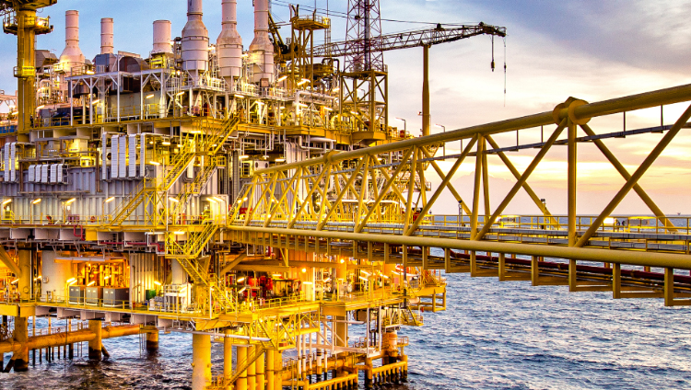
In 1964, Mike Hughes and Johnny Johnson formed a Gulf of Mexico diving company called Worldwide Divers. The company grew in response to increasing demand for their services and in 1969 merged with two other diving companies to form Oceaneering International, Inc.
Since the beginning, the company has transformed from a small regional diving company into a global provider of engineered products and services. Today, Oceaneering develop products and services for use throughout the lifecycle of an offshore oilfield, from drilling to decommissioning. they operate the world’s premier fleet of work class ROVs. Additionally, they are a leader in offshore oilfield maintenance services, umbilicals, subsea hardware, and tooling. They also serve the aerospace, defence, and theme park industries. With more than 50 years of experience providing inspection on critical infrastructure, Oceaneering deliver optimized, project-appropriate solutions that meet inspection criteria and ensure that your assets are fit for service. Their globally deployable solutions meet your critical and time-sensitive needs for non-destructive testing.
OFFSHORE INSPECTION USING THE JME BETATRON SYSTEM
Oceaneering Inspection Solution Combines High-Energy X-Ray and Digital Detector Array to Confirm Fitness for Service on Large-Diameter, Heavy Wall Risers Solution safely delivers high-resolution images and corrosion measurement data in near real time on an offshore installation.
PROJECT OVERVIEW
In January 2016, a client approached Oceaneering for a non-destructive testing (NDT) method that would be suitable for use on two risers in the North Sea. Each of the risers had significant external corrosion scale, also known as scabs – prompting the need for verification of the risers’ integrity. The goal was to extend the production timeline for the main oil line (MOL), which has a 24inch outside diameter (OD), and the gas producer, with a 20inch OD. The client required another year’s service from the risers in order to align the completion of its necessary repairs with the next planned turnaround.

ISSUES
The operator could not support or defend continued production without developing an integrity case to prove the risers’ fitness for service (FFS). Justification of FFS relies on accurate profiles of the flaws and, in this case, the remaining wall thickness figures around the full 360-degree circumference of the risers. The scale on the risers prevented direct access to the pipe surface and could not be removed for fear of puncture and product release, bringing with it production loss and potentially serious health, safety and environmental (HSE) issues.
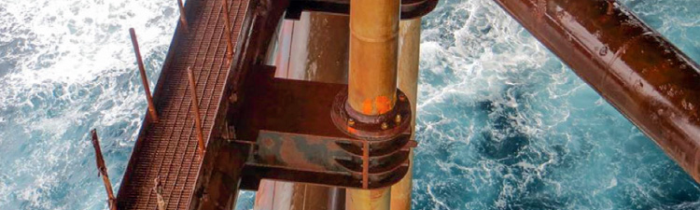
Oceaneering designed and manufactured customized hardware used to support the completion of the precise radiography. A project specific positioning trolley and radiation beam angle guide interfacing with the pipe flange ensured that each exposure was on target and that a comprehensive, accurate set of data was produced and used to assess the pipe thickness. The team also established a comprehensive health and safety plan, inclusive of extremely detailed exclusion areas and provisions, to ensure that personnel were not exposed to radiation. The project required an engineered scaffolding setup, and offshore preparation was completed prior to the mobilization of the radiography crew in May 2016. The radiography was conducted in 12-hour day shifts over two visits in an overall four-week period and was completed in June 2016.
CHALLENGES
Radiation safety, rather than a technical deliverable, was the primary challenge. This was overcome with detailed radiation dose profiling (with the beam directed toward the high-risk areas of the platform), along with special monitoring and detailed barrier plans. A twin-wire rigging system was used to lift and lower the heavy equipment from the deck level through a floor grating hole down to the scaffolding platform. Manual handling and positioning of the 220-lb (100-kg) accelerator head at the workface was achieved by fabricating a bespoke, wheeled support trolley and by rigging an overhead lifting beam in the radiation habitat. The location of the inspection site was only 39 feet (12 meters) from the sea, and, therefore, moisture, sea spray and salt, in combination with high winds and gusting, precipitated the need for an engineering-designed scaffold and weatherproofed habitat. Challenges in cable management, along with routing of the necessary communications and power from the system control habitat at emergency shutdown valve (ESDV) levels, were identified and overcome.
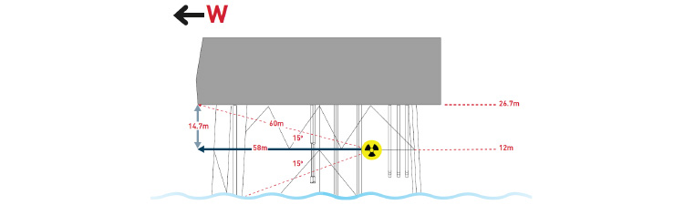
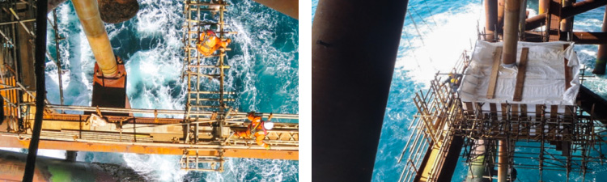
THE OCEANEERING SOLUTION
There was no conventional, industry-accepted NDT method or hardware capable of completing the required inspection. Without verification that the risers were fit for service, the operator was potentially exposing both personnel and the environment to a high level of risk. The position of the area needing inspection – just 39 feet (12 meters) above the lowest astronomical tide (LAT) – and the operator’s desire to keep operations online posed additional significant challenges. Oceaneering subject matter experts (SMEs) evaluated a range of possible options and concluded that radiography was the method with the most potential to deliver a solution; however, it was obvious that traditional X-ray or gamma sources lacked the energy required to complete the novel technique they envisaged.
Measuring the remaining wall thickness meant taking X-ray images around the circumference of each pipe tangentially. Although this is a conventional radiography technique, very powerful equipment capable of penetrating the very thick “chord” lengths of the risers was needed to complete multiple-angle exposures to ensure full area coverage. Oceaneering SMEs proposed a 7.5 MeV PXB betatron with digital detector array (DDA) radiography as a possible solution. A betatron is a very high-energy, highly penetrating source of X-radiation and had never been used offshore in conjunction with a DDA. The Oceaneering and client teams worked together to develop this industry-first operation. They established a comprehensive project plan that included trials; extensive safety planning; electrical, scaffolding and rigging teams; and the development of customized hardware.
EXECUTION PLAN
Using high-energy X-rays offshore was unprecedented, and, therefore, testing was required onshore to provide a degree of confidence that safe technical delivery was achievable. X-ray trials were conducted in a special facility in Rosyth, Scotland, in February 2016. These trials were completed using the planned tangential technique on a 24-inch-OD pipe to prove the concept. Two scoping visits were made to the platform to further understand the complexities involved with the project and to develop relationships with the client’s senior management team, including the offshore installation manager (OIM) and HSE representatives. These visits provided the platform personnel with an introduction to the inspection concept and gave the Oceaneering team the opportunity to view the work scope, particularly in relation to the positioning of the safe controlled area, exposure direction, and main personnel concentrations on the platform.
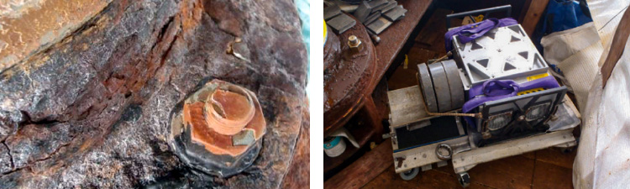
EQUIPMENT HIGHLIGHTS
- 7.5 MeV MXB betatron accelerator head
- Splash-proof covers for the power supply unit (PSU) and the accelerator head
- Special positioning trolley and angling device
- Specially fabricated collimation solution
- High-energy certified TRACERCO™ T202 Dose Rate Monitors
- A high-resolution, wireless digital detector array to deliver near-real-time digital X-ray images
PROJECT HIGHLIGHTS
- First time that high-energy X-rays and digital detector array radiography were used in combination on an offshore installation
- First time that the “tangential” technique has been used on this pipe thickness to provide wall-thickness information through heavy external corrosion scale
- First time that this information has been used for such a high-profile FFS exercise
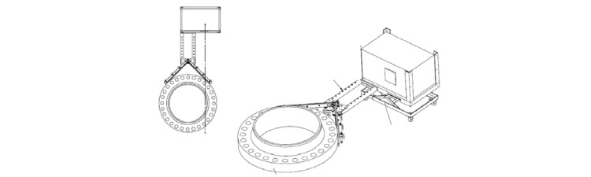
RESULTS - First time that high-energy X-rays and digital detector array radiography were used in combination on an offshore installation First time that the “tangential” technique has been used on this pipe thickness to provide wall-thickness information through heavy external corrosion scale First time that this information has been used for such a high-profile FFS exercise For this challenge, Oceaneering investigated possible methods, identified a solution, and completed the inspection of the risers by using its expertise in asset integrity and inspection methodologies. The solution provided significant cost savings and superior integrity assurance in a busy production environment on an offshore installation. The project identified a successful NDT solution for a degradation issue that is typically present on the many offshore installations with more than 20 years of production life. Oceaneering is confident that this extremely powerful inspection combination can be a useful tool in the U.K. Health and Safety Executive’s Key Programme 4 (KP4) Ageing and Life Extension (ALE) program’s search for inspection options.
