**How 2D Digital Radiography Enhances Automotive and Aerospace Quality Control**

**Introduction**

In the competitive landscape of automotive and aerospace manufacturing, ensuring the integrity of foundry castings is critical. This case study delves into North Star Imaging (NSI)’s successful application of 2D Digital Radiography (DR) and automation within foundry casting environments. It addresses the industry’s shift toward lightweighting and the demand for complex, high-quality solutions. By leveraging NSI’s advanced DR X-ray systems, Production Module, Motion Programming, Assisted Defect Recognition (ADR), and robust reporting functions, this study showcases a transformative approach to quality control, balancing efficiency with precision.

**Customer Challenge / Opportunity**

A prominent foundry casting company faced escalating challenges due to surging production demands, the intricacies of X-ray requirements, cost of consumables, and the high level of expertise needed for accurate interpretation. Traditional methods struggled to keep pace, risking delays and inconsistent defect detection. This presented an opportunity to implement a streamlined, automated solution to enhance throughput, repeatability, and cost-effectiveness while reducing reliance on specialized personnel and high turnover.

**Product Overview**

NSI offers a comprehensive solution that integrates its DR X-ray System with the Production Module, Motion Programming, ADR, and reporting capabilities. This approach highlights a seamless workflow that minimizes manual intervention, optimizes part handling, and delivers actionable insights. By emphasizing automation and advanced image analysis, NSI positions itself as a partner to aerospace and automotive customers capable of meeting the evolving needs of high-throughput manufacturing environments.

**Case Study Details:**

**Samples**

The study utilized three aluminium cast valve covers from a V10 engine, selected for their relevance to casting industry challenges. These parts exhibited natural defects such as gas porosity, shrinkage, inclusions, and dross, while simulated cracks were introduced across varying wall thicknesses—from thin to thick zones—to test detection limits. This diversity ensured a robust evaluation of the system’s capabilities.

**Fixturing**

A 3D-printed carbon fiber PLA fixture, designed by Chase Lemmer Scanning Services Technician, held the three valve covers securely. This fixture’s low attenuation and high strength, enhanced by carbon fiber rods, allowed multi-part imaging with image quality indicators positioned out of the way yet accessible. The multi-part design reduced material use while increasing productivity by minimizing human interaction, showcasing an innovative approach to fixturing.

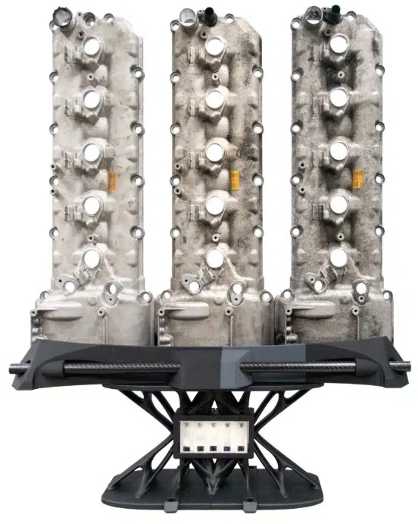 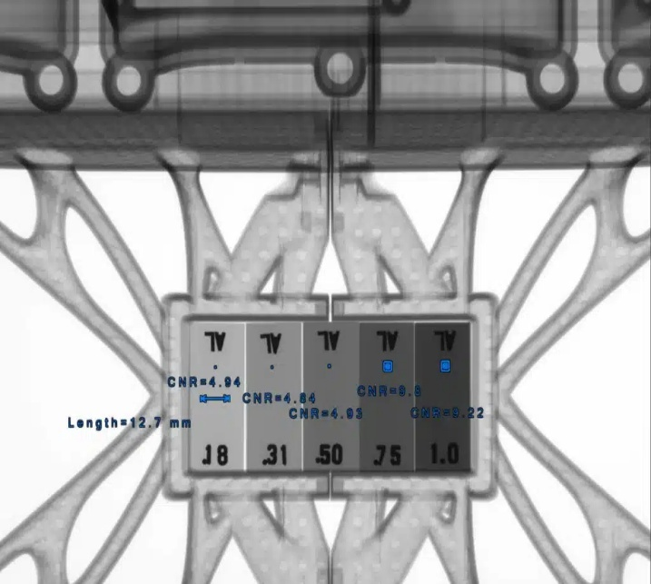

**Motion program**

When comparing manual setup of film techniques to the speed of motion programs in digital radiography it is generally known that there can be a four to ten times improvement in speed alone. Using film radiography an average exposure time on an aluminium casting is about 30 seconds and the setup of that exposure can take at least 30 seconds (including tube ramp up/down, door time, etc.). Shifting this setup to digital would net an imaging time of around 3 seconds with no setup, and no down time between image exposure acquisitions. The motion program using PLC driven multi-axis manipulation allows for quick simple exchanges between radiographic views.

<https://4nsi.com/wp-content/uploads/2025/05/iqis.mp4>

Additionally, each step in the motion program not only captures the motion of the axis but also all the x-ray tube, detector, and image overlays (annotations, filters, histogram settings, etc.)

**Capturing images**

NSI’s software allows the user to preconfigure window levels, widths, filtering, and contrast-to-noise calculations all stored within the motion program, eliminating repetitive setup. This allows interpreters to focus on evaluation, significantly accelerating analysis and enhancing efficiency in production settings.

**Production Module**

The DR Production Module supports high-volume environments with part traceability via customizable naming conventions using the customer part traveller and integrating into NSI’s software. DICONDE formats further enhance metadata traceability, linking images to lot, batch, melt, or serial numbers. With minimal training, operators can load parts, scan barcodes, and initiate the motion program, freeing time for preparing the next set while the system operates autonomously.

**Manual Inspection and Interpretation: Film vs Digital**

When performing manual interpretation in film radiography there are many intricacies of the process. Everything from storage for all the film, and tools such as wax pencils, scratch resistant gloves, viewers, densitometers, light meters, optical microscope, etc. The true time for evaluating a radiograph is heavily dependent on the skill and efficiency of the interpreter and can require years of experience before either of these dependencies are met.

Utilizing Digital Radiography

Increase efficiency and reduce the need for specialized skills:

* Simplify Tools: Replace traditional tools with a computer, keyboard/barcode scanner, mouse, and monitor.
* Reduce Imaging Time (4x-10x faster):
  + Use Digital Detector Array (DDA) technology for faster exposures.
  + Minimize door and x-ray tube ramp times via PLC motion control and multi-part fixturing.
* Speed Up Processing: Cut radiograph processing from 10-12 minutes (film) to 2-5 seconds (digital).
* Lower Expertise Needs: Automate complex tasks to reduce reliance on Level 1, 2, or 3 experts onsite.
* Simplify System Operation:
  + Enable minimally trained users to operate by loading parts, scanning a barcode, and pressing “go.”
* Boost Setup Efficiency: Allow operators to prepare the next parts while the system captures images.
* Streamline Image Access:
  + Store images in a shared network pathway.
  + Use one barcode scan to log part data, automatically queuing images with traceable file names.
* Minimize Radiograph Manipulation:
  + Apply view properties in the motion program to reduce clicks for annotations and measurements.
  + Use image presets to limit adjustments to software tools.
  + Enable digital radiographic comparison with reference or gold standard images.
* Improve Traceability and Reduce Errors:
  + Store image metadata for part acceptance.
  + Save all image-to-part traceability and process data.
  + Automatically archive data to server-based storage.

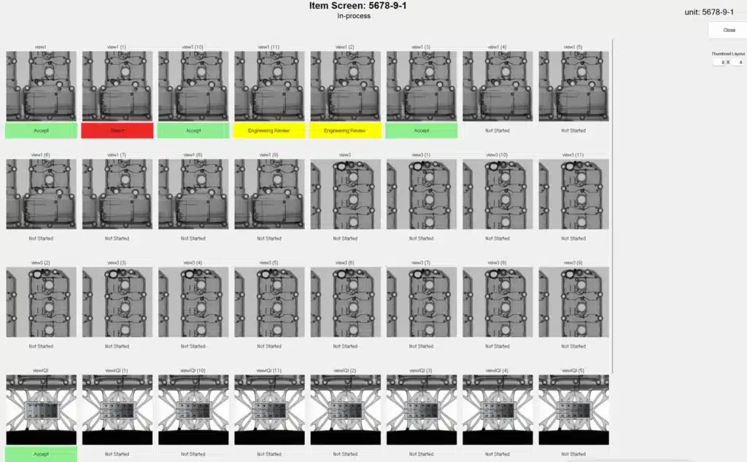

**ADR Interpretation**

ADR software overview:

efX-ADR is an Assisted Defect Recognition software designed to enhance production workflows with a linear, intuitive user interface that integrates seamlessly into the efX software suite. It supports automatic processing of high-volume products, improving throughput, repeatability, and cost-efficiency while reducing interpretation inconsistencies. Users can select from various defect-detection mechanisms tailored to their parts, leveraging features like fast GPU-based image processing, compatibility with TIF, PNG, and DCM formats, CT slice compatibility, command line mode, folder monitoring, copy/move/delete functions, process control incorporation, computer accept/reject status, defect heatmaps, and customizable CSV output for business intelligence integration.

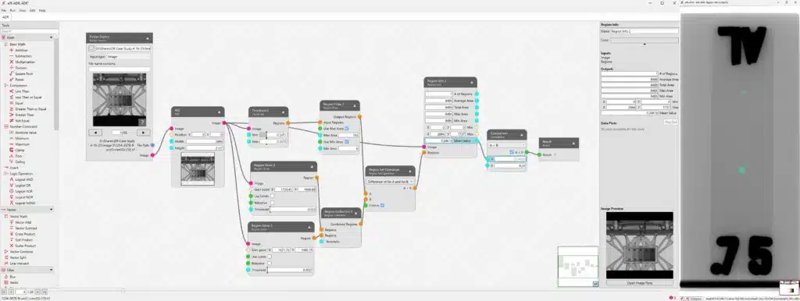

Ideal for high-volume products, those with inconsistent manual interpretations, monotonous evaluations, missing component checks, position assessments, or existing difficult-to-configure ADR solutions, efX-ADR offers automatic monitoring of contrast, CNR, SNR, mean value variations, spatial resolution, min-max limits, warning and stop boundaries, and regular evaluations with known defect standards.

**ADR Production Module**

This feature enables batch processing of ADR workflows for part families, scaling efficiency across production lines.

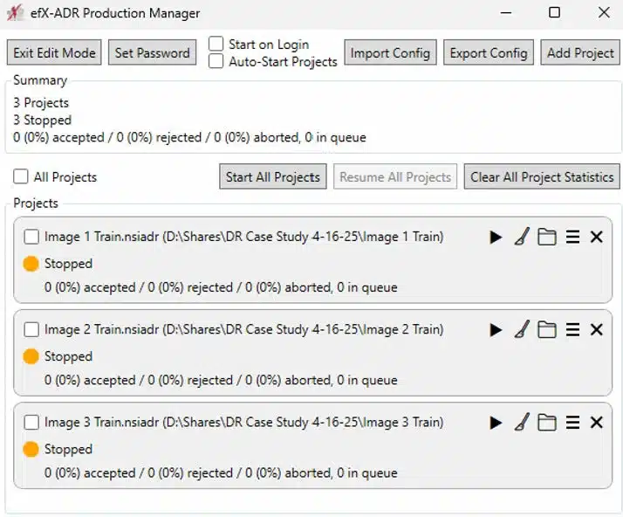

**Time Study**

Across the images captured it took a manual operator roughly 60 seconds to evaluate and annotate each image, while efX-ADR processed each image in roughly 1.5 seconds. The program can evaluate the indication regions found in the image based on specific evaluation criteria as determined by the user and in this case, we used maximum area. There is a series of versatile tools that allow the user to build a customizable workflow evaluation output from a rule-based image processing chain.

**Manual + ADR Interpretation**

In the digital radiographic process, image evaluation is generally considered the bottleneck for time. When adding the efficiencies gained from efX-ADR we can see a reduction in overall image evaluation of up to 30% potentially increasing daily radiograph assessments from 480 to 624, or 36,000 more annually per interpreter. This efficiency gain transforms production capacity.

**Detection Rate**

In a small case study, we evaluated the repeatability and reproducibility of detecting specific indications in castings using a 60-second motion program, conducted over three days. Parts were unloaded and reloaded between each run to test reproducibility. The study focused on detecting four indication types: foreign material denser (inclusions), shrinkage, gas porosity, and simulated cracks. Detection of inclusions, shrinkage, and gas porosity achieved repeatability and reproducibility of 99% or higher. Simulated cracks were more challenging, particularly in material thickness transition zones. A rule-based image processing chain was configured to identify all four indication types.

**Indications part of this study:**

Note – Indication size filter applied to threshold only known repeatable indications

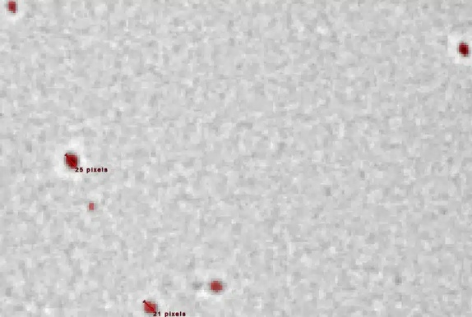 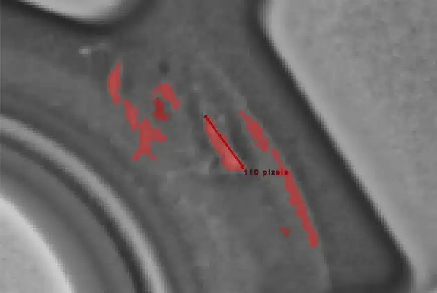

Inclusions (Size filter: min 20 pixels) Shrinkage (Size filter: min 100, max 120 pixels)

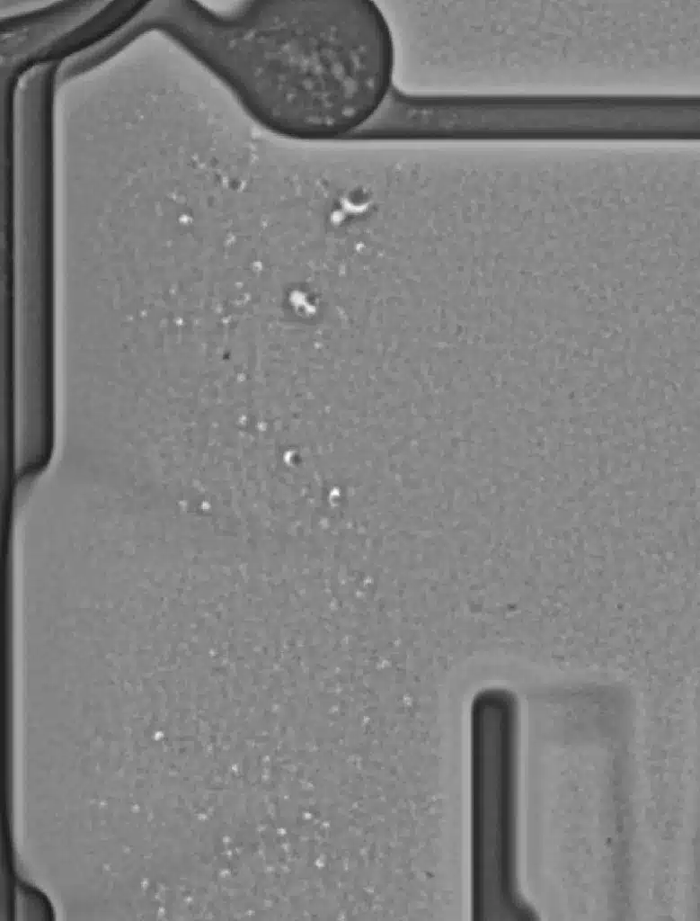 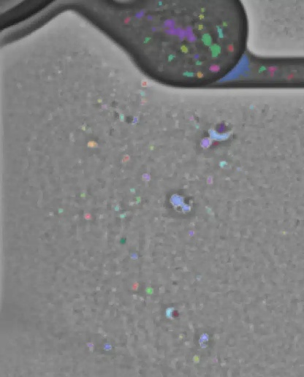 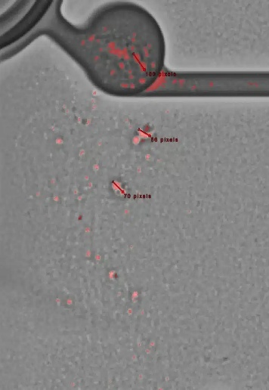

Gas Porosity (50 pixels) Original Image ADR threshold ADR annotation

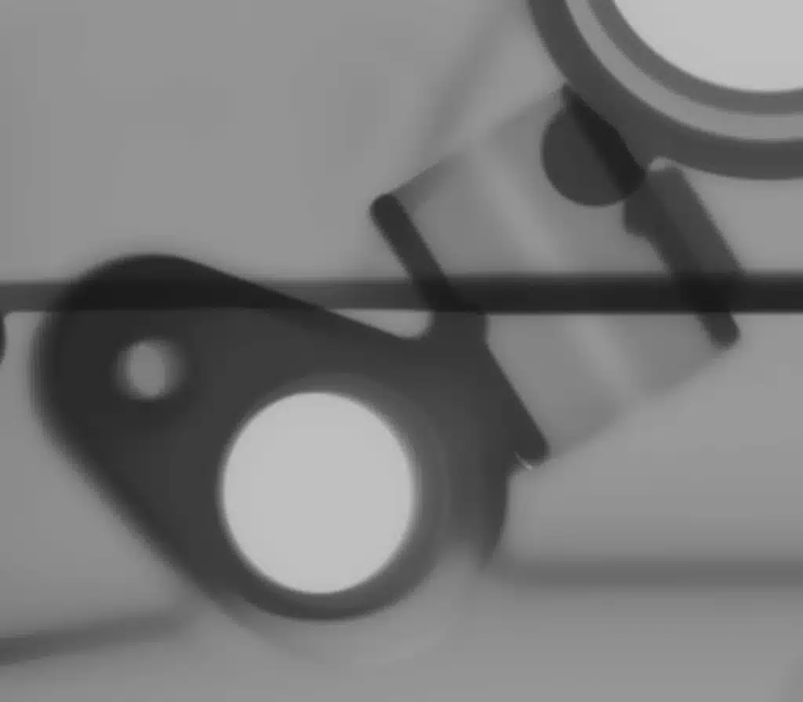

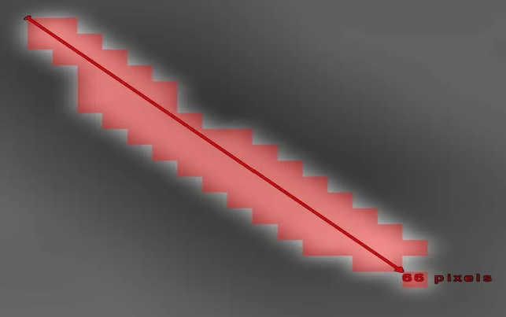

Simulated Cracks (50 pixels)

**Summary**

This report analyses the performance of an Assisted Defect Recognition (ADR) using an automated processing system across 360 trials, focusing on repeatability of detection in radiographic testing. Key metrics include Repeatability of Detection and Pixel Coverage. The ADR processing time is consistently 1.5 seconds per image.

* Overall Average Repeatability of Detection: 97.25%
* Defect Types Analysed: 4
* The defect type “Simulated Crack” has the lowest average Repeatability of Detection at 86.97%, indicating potential challenges in detection.

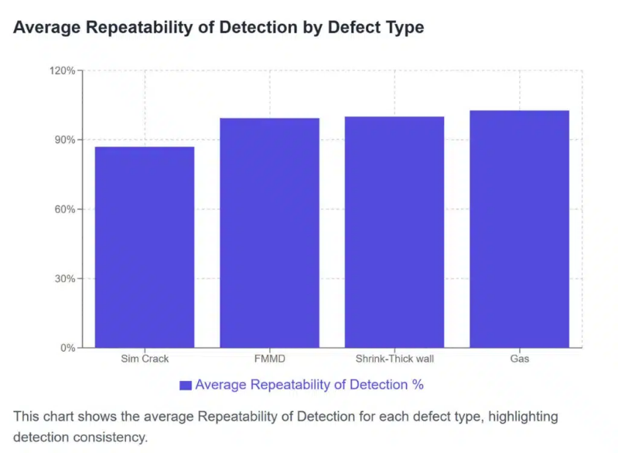

**Heat Map**

In engineering, comparing actual product output to designed input is crucial. The efX-ADR system provides a valuable feature that helps engineers pinpoint problem areas in parts. Its heat map analysis a large set of Automated Defect Recognition (ADR) images, identifying indication locations and displaying them as shaded, color-coded spatial mappings based on severity.

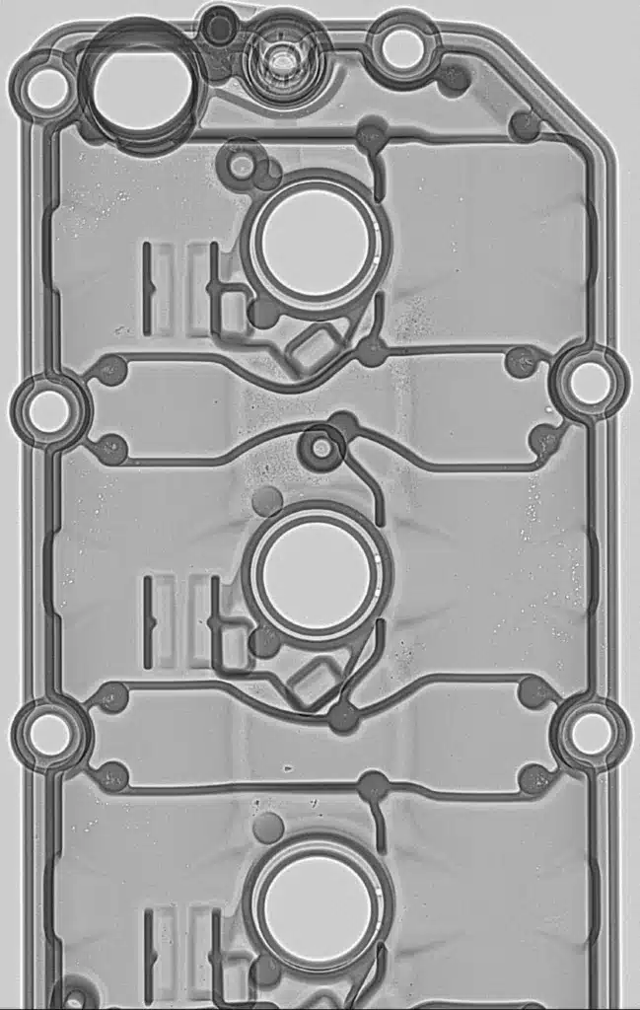 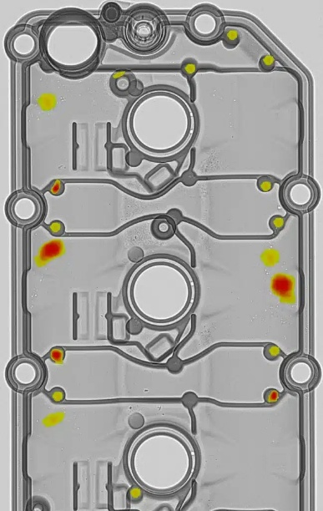

**POD and TPR per ASTM E3327**

ASTM E3327 provides a detailed framework for calculating Probability of Detection (POD) and True Positive Rate (TPR), offering a standardized method for validating ADR performance.

**Output and Reporting**

Effective reporting and data output are critical for L2 and L3s to communicate effectively to engineers, allowing them to monitor and optimize their processes. Clear, actionable data provides insights into performance, bottlenecks, and trends, enabling engineers to make informed decisions. By tracking key metrics, engineers can identify areas for improvement, streamline workflows, and enhance efficiency. Well-structured reports transform raw data into meaningful information, empowering engineers to refine their processes and achieve better outcomes.

efX-Review’s Tile-View and user acceptance overrides features, alongside efX-ADR’s workflow design and CSV outputs, support robust analysis. KPIs from CSV data, like the example shown for thick wall shrinkage metrics in this aluminium casting, further enhance business intelligence integration.

efX-Review:

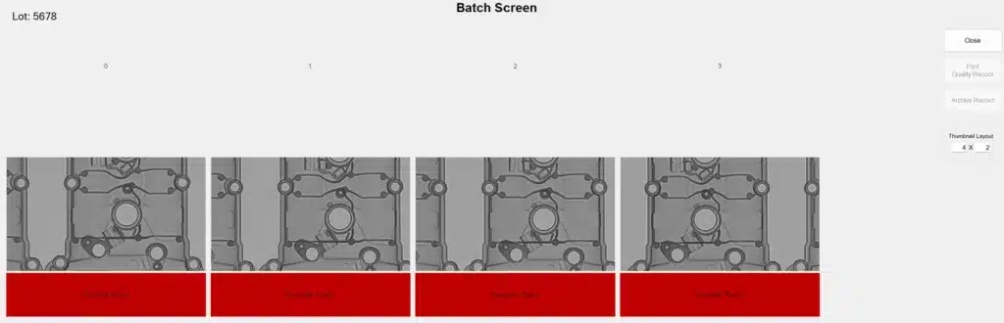

Tile-View showing an overall view of the different units in the batch

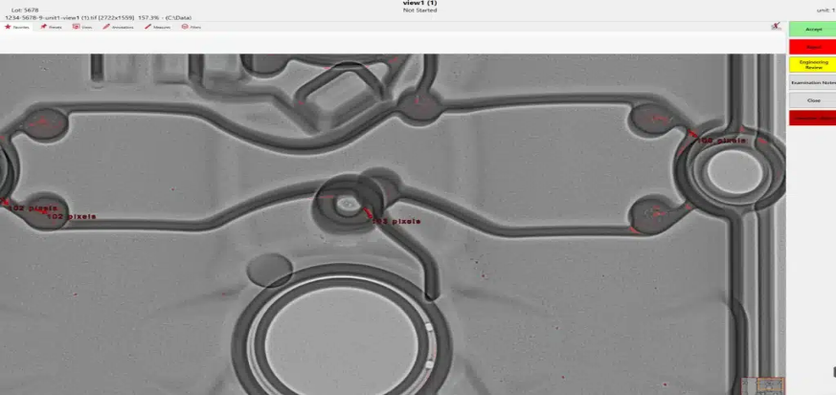

User override of computer accepts or reject

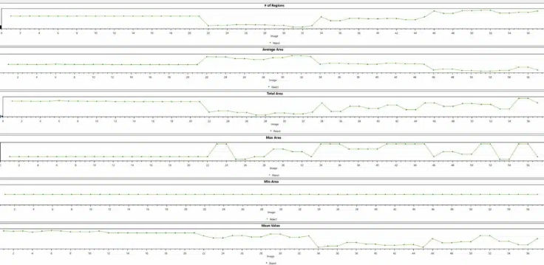

efX-ADR Workflow Chain Design and Evaluation

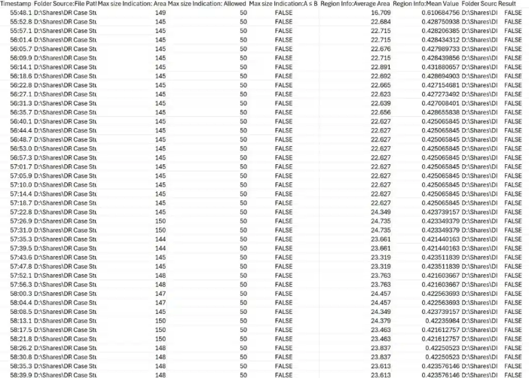 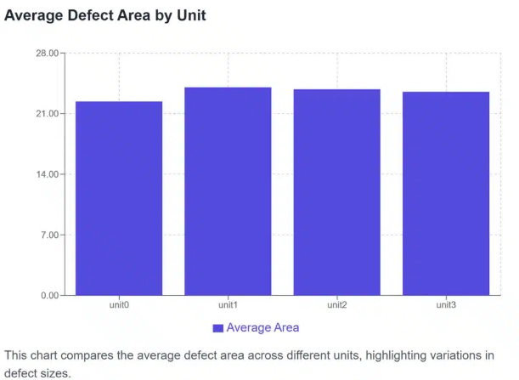

efX-ADR CSV Output for Business Intelligence Integration Creating KPI’s around efX-ADR CSV data metrics

Example: Thick Wall Shrinkage

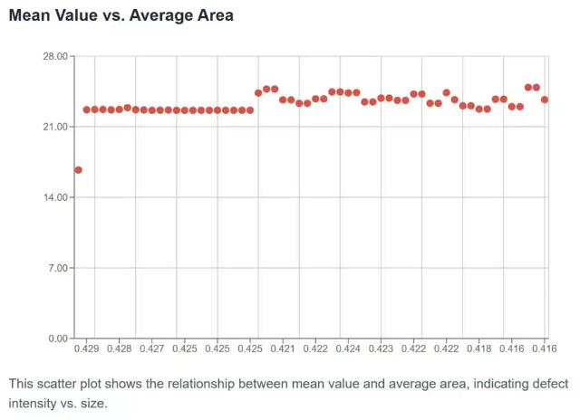 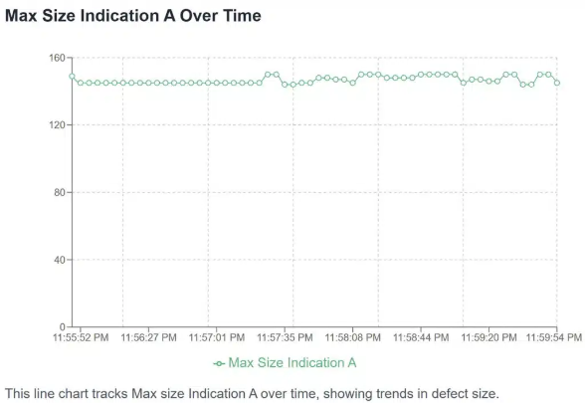

**Archival: Long Term Storage, DCM, and Servers**

Proper long-term storage of radiographs, particularly in the DICONDE format, ensures their preservation, traceability, and accessibility for future reference. DICONDE, a standardized digital format, enhances interoperability across systems, maintaining image quality and metadata integrity over time. Traceability allows engineers to track the history, origin, and context of each radiograph, supporting quality control, audits, and compliance with industry standards. This organized approach facilitates efficient retrieval, reduces data loss risks, and enables analysis for process improvements, ultimately enhancing reliability and decision-making in engineering workflows.

The efX-DCM software program eliminates the challenges of film-based processes. Its key benefits include:

* Elimination of Film Storage: Replaces bulky film warehouses with digital storage, freeing up space.
* Streamlined Access: Removes the need to search for job-specific film crates, simplifying retrieval.
* Cost Savings: Cuts warehouse-related expenses, reducing operational overhead.
* Enhanced Traceability and Searchability: Leverages image metadata for improved organization and quick access to images.
* Durable Long-Term Storage: Ensures digital images remain high-quality over time, without degradation concerns.

These advancements make radiography more efficient, cost-effective, and reliable.

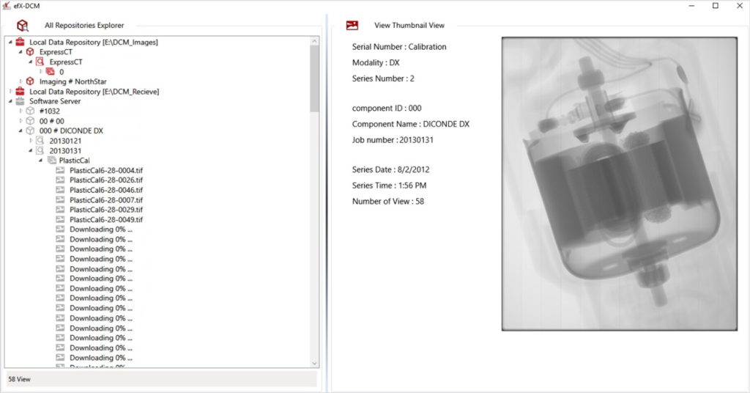

EFX-DCM DICONDE MANAGEMENT​

**In Review**

The case study highlights North Star Imaging’s 2D Digital Radiography (DR) systems and software as transformers for quality control in automotive and aerospace foundry casting. By integrating advanced automation, efX-ADR software, and DICONDE-based archival, NSI achieves remarkable efficiency gains, reducing image evaluation time by up to 30% and boosting annual radiograph assessments significantly. The system’s high repeatability (97.25% overall) and robust traceability ensure reliable defect detection. Innovative fixturing and comprehensive reporting empower engineers with actionable insights, while long-term DICONDE storage enhances data accessibility and process optimization. This solution defines precision and productivity in high-throughput manufacturing.